6) Write a python program to implement List methods (Add, Append, Extend & Delete)?

PROGRAM:
# List Methods Program
# Initial List
numbers = [10, 20, 30]
print("Original List:", numbers)
# 1. append() → Add item at end
numbers.append(40)
print("\nAfter append(40):", numbers)
# 2. insert() → Add item at specific position
numbers.insert(1, 15) # Insert 15 at index 1
print("After insert(1, 15):", numbers)
# 3. extend() → Add multiple items
numbers.extend([50, 60])
print("After extend([50, 60]):", numbers)
# 4. remove() → Delete by value
numbers.remove(20) # Removes first occurrence of 20
print("\nAfter remove(20):", numbers)
# 5. pop() → Delete by index
numbers.pop(2) # Removes item at index 2
print("After pop(2):", numbers)
# 6. del keyword → Delete slice or full list item
del numbers[1] # Delete element at index 1
print("After del numbers[1]:", numbers)

OUTPUT:
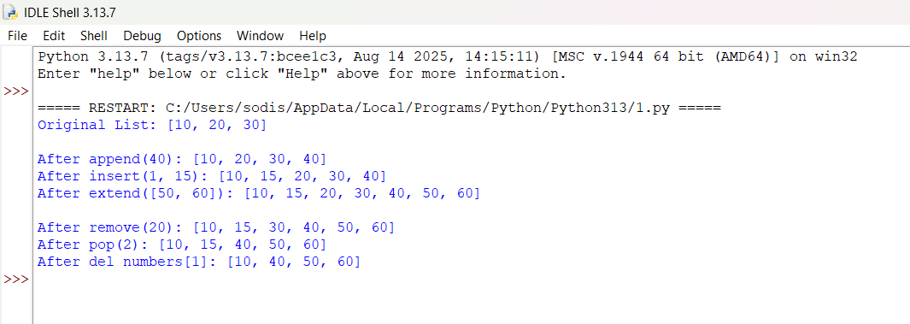

OUTPUT:



